**Project Initialization and Planning Phase**

| Date | 8 July 2024 |
| --- | --- |
| Team ID | team-740034 |
| Project Name | Predicting the Energy Output Of Wind Turbine Based On Weather Condition |
| Maximum Marks | 3 Marks |

**Define Problem Statements (Predicting the Energy Output Of Wind Turbine Based On Weather Condition):**

The problem statement for predicting the energy output of a wind turbine based on weather conditions typically involves developing a model that can accurately forecast the electricity generation of a wind turbine given various meteorological parameters. Here’s a structured version of the problem statement:

**Problem Statement:**

Develop a predictive model to estimate the energy output (in kilowatt-hours) of a wind turbine based on current and forecasted weather conditions. The model should utilize historical data of weather parameters such as wind speed, temperature, humidity, and air pressure to predict the electricity generation capacity of the wind turbine accurately.

**Example:**

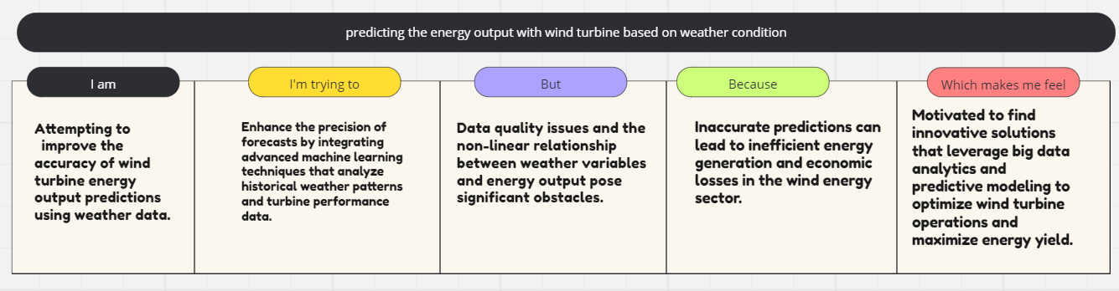

| **Problem**  **Statement (PS)** | **I am**  **(Customer)** | **I’m trying to** | **But** | **Because** | **Which makes me feel** |
| --- | --- | --- | --- | --- | --- |
| PS-1 | Trying to predict the energy output of wind turbines based on weather conditions. | Develop a model that accurately forecasts the electricity generated by wind turbines given varying weather parameters such as wind speed, temperature, and humidity. | Existing models often struggle to account for the complex interactions between these weather variables and their impact on turbine performance. | Weather conditions can fluctuate rapidly and unpredictably, affecting wind turbine efficiency and output. | Frustrated by the challenge of creating a reliable forecasting tool that can optimize wind energy production under diverse weather scenarios. |
| PS-2 | Attempting to improve the accuracy of wind turbine energy output predictions using weather data. | Enhance the precision of forecasts by integrating advanced machine learning techniques that analyze historical weather patterns and turbine performance data. | Data quality issues and the non-linear relationship between weather variables and energy output pose significant obstacles. | Inaccurate predictions can lead to inefficient energy generation and economic losses in the wind energy sector | Motivated to find innovative solutions that leverage big data analytics and predictive modeling to optimize wind turbine operations and maximize energy yield. |